ROAD ANOMALY DETECTION
Project Title:
Deep Learning Framework for Road Anomaly Detection and Classification with Edge Deployment on Raspberry Pi
Abstract:
Road surface anomalies such as potholes, cracks, and surface deformities significantly affect driving safety and vehicle performance. Accurate and real-time detection of these anomalies is essential for intelligent transportation systems and smart mobility applications.
This project proposes a multi-model deep learning framework for road anomaly detection and classification using state-of-the-art lightweight architectures including Vision Transformer (ViT), YOLOv8, EfficientNet, MobileNetV2, ShuffleNetV2, and GhostNet.
The models were trained and evaluated on a structured road anomaly dataset. Performance comparison was conducted using accuracy, precision, recall, F1-score, and confusion matrix analysis.
The best-performing lightweight model was exported to ONNX format for deployment on Raspberry Pi, ensuring real-time edge-based inference with minimal computational overhead.
Experimental results demonstrate that lightweight CNN architectures such as YOLOv8 Nano and ShuffleNetV2 achieve high classification accuracy while maintaining low memory and computational complexity, making them suitable for real-time road monitoring systems.
1. Introduction
Road anomalies such as potholes and cracks are major contributors to vehicle damage and road accidents. Traditional inspection methods are manual, time-consuming, and inefficient.
Deep learning-based computer vision systems provide automated, scalable, and real-time solutions for detecting road surface anomalies.
This project focuses on:
- Developing a comparative deep learning framework
- Evaluating multiple modern architectures
- Selecting an optimal model for edge deployment
- Deploying the trained model on Raspberry Pi
The objective is to design a lightweight yet accurate system suitable for intelligent transportation and smart city applications.
2. Methodology
The proposed system follows a structured deep learning workflow:
2.1 Dataset Preparation
The road anomaly dataset was organized into structured folders based on class labels (e.g., Pothole, Crack, Normal Road).
Steps involved:
- Image collection and labelling
- Train–Validation–Test split (80:20)
- Image resizing to 224×224 pixels
- Image normalization
- Data augmentation (rotation, flipping, brightness adjustment)
- Contrast enhancement using CLAHE
- Edge-based enhancement for anomaly emphasis
These preprocessing steps improved model generalization and robustness.
2.2 Model Selection
Multiple modern deep learning architectures were selected for comparative analysis:
S.NO | MODEL NAME | ARCHITECTURE TYPE
1. | Efficient Net Lite | CNN
2. | MobileNetV2 | CNN
3. | ShuffleNetV2 | Lightweight CNN
4. | Yolov8 Nano | CNN
5. | Vision Transformer(vit) | Transformer-based

Selection criteria included:
- Lightweight architecture
- High inference speed
- Low memory usage
- Suitability for Raspberry Pi deployment
2.3 Model Training
Training was performed using:
- Platform: Google Colab
- Framework: PyTorch / Ultralytics YOLOv8
- Image Size: 224×224
- Batch Size: 16
- Epochs: 10–20
- Optimizer: Adam
- Loss Function: Cross-Entropy Loss
Transfer learning with pretrained ImageNet weights was used to improve training efficiency and convergence speed.
2.4 Model Evaluation
Each model was evaluated using:
- Accuracy
- Precision
- Recall
- F1-Score
- Confusion Matrix
- Training and Validation Loss Curves
- Error Graphs
Comparative analysis helped determine the best-performing architecture for deployment.
3. Results
The performance comparison of models is summarized below:
Model | Test Accuracy
EfficientNet Lite | 36.12%
MobileNetV2 | 73.54%
ShuffleNetV2 | 93%
GhostNet | 92%
YOLOv8 Nano | 95.6%
Vision Transformer (ViT) | 83.00%

Best Performing Model:
YoloV8 Nano– 95.2% Accuracy
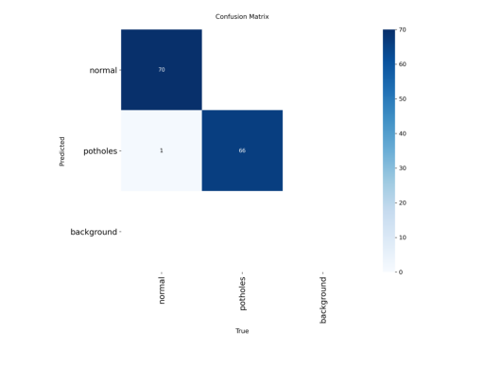
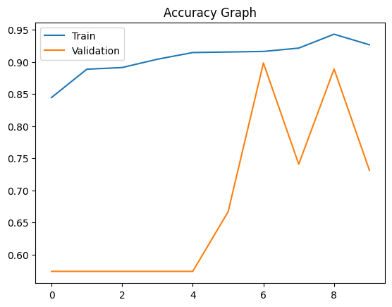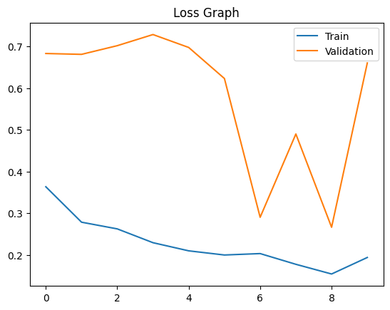

Performance Metrics (YoloV8 Nano ):
- Accuracy: 95.2%
- Precision: 0.815
- Recall: 0.7935
- F1-Score: 0.7989

Confusion matrix analysis shows strong classification capability with minimal misclassification between anomaly and normal road conditions.
Training graphs show steady convergence and stable validation performance.
4. Hardware Utilization
4.1 Training Environment
- Platform: Google Colab
- Processor: CPU / GPU (when available)
- Framework: PyTorch / Ultralytics
- RAM: 12GB (Colab environment)
Cloud-based training enabled faster experimentation and hyperparameter tuning.
4.2 Deployment Environment
- Device: Raspberry Pi 4
- RAM: 4GB
- OS: Raspberry Pi OS
- Inference Engine: ONNX Runtime
- Model Format: ONNX
The lightweight nano architecture ensures:
- Reduced memory usage
- Faster inference speed
- Low power consumption
- Real-time processing capability
5. Optimization Techniques
Several optimization strategies were implemented:
5.1 Transfer Learning
Using pretrained weights reduced training time and improved model accuracy.
5.2 Image Preprocessing Enhancements
- CLAHE for contrast enhancement
- Edge-based sharpening
- Noise reduction
- Data augmentation
These improved anomaly feature visibility.
5.3 Lightweight Architecture Selection
Nano and mobile-based architectures were selected to ensure deployment feasibility.
5.4 Hyperparameter Tuning
- Learning rate optimization
- Batch size adjustment
- Epoch tuning
- Dropout regularization
Improved generalization and reduced overfitting.
5.5 ONNX Model Conversion
Model exported to ONNX for:
- Faster inference
- Platform independence
- Reduced latency
- Edge-device compatibility
6. Conclusion
This project successfully developed a comparative deep learning framework for road anomaly detection and classification. Multiple modern architectures were evaluated, and YOLOv8 Nano achieved the highest classification accuracy while maintaining low computational complexity.
The integration of transfer learning, image enhancement techniques, and lightweight architectures ensures real-time deployment capability on Raspberry Pi.
The proposed system demonstrates strong potential for smart road monitoring, intelligent transportation systems, and automated infrastructure maintenance.

